*April 9th, 2018*

**3 Formulating the Assignment Problem as a Mathematical Problem**

The ***equivalent minimization method*** is used for finding equilibrium over networks with a larger number of nodes, links, and O-D pairs, leading to an optimal solution as the ***user-equilibrium flow pattern***.

The focuses of this chapter are on ***the formulation of the equivalent minimization program*** corresponding to the equilibrium traffic assignment problem and ***on the properties*** of this program.

This chapter is organized as follows:

Section 3.1 presents the equivalent minimization formulation.

Section 3.2 shows the solution satisfies the equilibrium conditions.

Section 3.3 proves that the solution is unique.

Section 3.4 and 3.5 explore the nature of the minimization program and the user-equilibrium flow pattern.

The network itself is represented by a directed graph, with the following notations:  
: a set of consecutively numbered nodes;

: a set of consecutively numbered arcs (links);

: the set of origin centroids;

: the set of destination centroids;

:O-D pair r-s, which is connected by a set of paths(routes). and .

: the origin-destination matrix;

: the entries of O-D matrix, that is, the trip rate between the origin and destination ;

: the flow on link ;

: the travel time on link ; the link performance function (or volume-delay curve, link congestion function), represents the relationship between the flow and the travel time for link ;

: the flow on path  connecting origin  and destination ;

: the travel time on path  connecting origin  and destination ;

: indicator variable,  if link a is a part of pathconnecting O-D pairand. otherwise.

The travel time of a particular path is the sum of the travel time of the links along this path, which can be expressed mathematically as:

[3.1a]

The link flow can be expressed as a function of the path flow, that is

[3.1b]

Equations [3.1] are known as the ***path-arc incidence relashionship.(路径路段关联关系).***

The above presentations can be simplified by using vector notation, then, let

;

;

;

;

;



：***the link-path incidence matrix*** with elements . ，whereis the link-path incidence matrix for O-D pair ,.

The travel time of particular path and the flow of a particular link(incidence relationship) can be written in matrix notation as:  
[3.2]

As shown in figure 1, the incidence matrix for the example network can be written as follows:  
 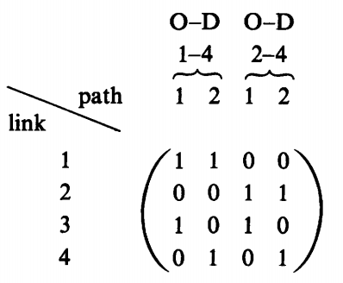

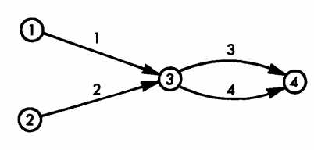

Figure 1 Network example with two O-D pairs and four links

**3.1 The basic transformation**

The equilibrium assignment problem is to find the link flows, , that satisfy the user equilibrium criterion when all the origin-destination entries, , have been appropriately assigned.

This link-flow pattern can be obtained by solving the following mathematical program:  
[3.3a] (网络系统中所有弧段出行时间总和最小是每个用户都选择出行时间最小的路径的结果，出行时间是流量的函数，流量定了出行时间也定了，因此本问题是寻求满足规划的*各弧段流量*)

Subject to（约束条件都是流之间的关系，对任意o-d pair 和对任意一个弧段）

[3.3b]（*路径流量*与O-D对流量的关系，把任意od的总流量分配到各路径中,寻求*路径流量*）

[3.3c]

The definitional constraints

[3.3d] （*弧段流量与路径流量*的关系）

The problem formulation represented by Eqs. [3.3] is known as ***Beckmann's transformation***. Equation [3.3b] represents all O-D pair rates have to be assigned to the network. The objective function [3.3a]of program is formulated in terms of link flows, whereas the flow conservation constraints are formulated in terms of path flows. The network structure enters this formulation through the definitional ***incidence relationships***[3.3d]. These incidence relationships indicate that the partial derivative of link flow can be defined with respect to a particular path flow. In other words:

 [3.4]

A typical performance curve is depicted in Figure 3.3.1. There are two assumptions on the performance curve.

The travel time on a given link is the function of flow on that link only and not of the flow on any other link in the network. That can be written mathematically as:

[3.5a]

Second, the link performance functions are assumed to be positive and increasing. That is :  
 [3.5b]

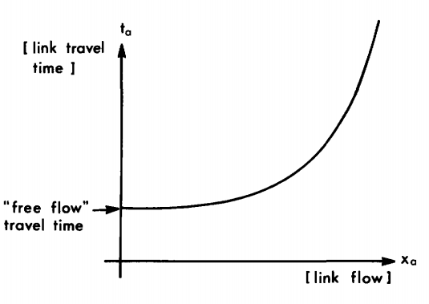

Figure 3.1.1 typical link performance function, 

**3.2 Equivalency conditions**

The equivalency conditions is demonstrated by proving that the first-order conditions for the minimization program are ***identical*** to the equilibrium conditions. Thus, find a minimum point of the program, an equilibrium flow pattern is obtained. (目标函数是多个performance function 的和，因此在定义域内是严格凸函数，如果定义域也是凸的，那么一阶条件求出的驻点即是program的全局极小点，由于一阶条件与平衡条件一致，因此目标函数的极小点满足平衡条件. 所以重点是如何证明一阶条件与平衡条件一致)

To derive the first-order condition of the Beckman transformation, observe that it is a minimization problem with linear equality and nonnegative inequality. Firstly, the Lagrangian of the equivalent minimization problem with respect to the equality constraints can be formulated as:  
 [3.8a]

Subject to  [3.8b]

Where denotes the dual variables associated with the flow conservation constraint for O-D pair in Eqs. [3.3b].

The first-order condition(stationary point) of the Lagrangian with respect to path-flow variables can be formulated as:  
 [3.9a]

With respect to dual variables:

 [3.9b]

 [3.9c]

The partial derivatives of  with respect to the flow variables  is given by:  
[3.10]

The first term on the right-hand side of Eq. [3.10] can be evaluated by using the chain rule:

[3.11]

[3.12a]

[3.12b] (as shown in Eq.[ 3.4])

Thus, the Eq. [3.11] becomes:  
[3.13]

The second term on the right-hand side of Eq. [3.10] is even simpler to calculate since:



[3.14]

The partial derivatives of  with respect to the flow variables  (Eq. [3.10]) becomes

[3.15]

The general first-order conditions (Eqs. [3.9]) for the minimization program in Eqs. [3.3] becomes:  


Eqs [3.16a] [3.16b] and [3.16d] indicate two possible combinations of path flow and travel time, that is

 or 

In any event, for any given origin  and destination , . That is , the Lagrangian multiplierequals the minimum path travel time between origin  and destination .

According to the first-order conditions, the paths connecting any O-D pair can be divided into two categories:

(1)carrying flow, on which the travel time equals the minimum O-D travel time;

(2)not carrying flow, on which the travel time greater than or equal to the minimum O-D travel time.

If the flow pattern satisfies the firsr-order condition, no motorist can improve his travel time by unilaterally changing routes. That is just the user-equilibrium principle. As to Eq. [3.16c], is must be satisfied whether in first-order conditions or in user-equilibrium principle.

总结：最初，构造函数的一阶条件，只是为了寻找函数的驻点，满足一阶条件即是函数的驻点。现在，一阶条件是连接极小值与用户平衡之间的桥梁。构造函数的一阶条件，求解驻点，再证明函数和可行域都凸，驻点即是极小点，由于一阶条件与用户平衡等价，因此该极小点也满足用户平衡。因此，只寻找函数的极小点，即是满足用户平衡条件的flow pattern。在大型网络问题中，求解时没有必要再去建立一阶条件，只需要构造原问题的equivalent minimization program, 然后用软件计算其极小值即可，因为建立的一阶条件也会很复杂，同样难以用手算的方式求出来。

**3.3 Uniqueness conditions**

In order to show that the UE equivalent minimization program has only one solution, the following conditions should be satisfied:  
 (1) the objective function[3.3a] is strictly convex in the vicinity of (and convex elsewhere)

(2) the feasible region(defined by [3.3b] and [3.3c]) is convex.

The convexity of feasible region is assured for linear equality constraints, and the addition of nonnegative constraints does not alter this property. The focus of this section is on the analytical ***properties of the objective function***.

The convexity of the objective function is proved here with respect to link flows, path flows are treated later.

Assum that the link performance function is related to that link only and it is positive and increasing. That can be formulated as (see Eq.[3.5]):

[3.5a]  
 [3.5b]

This section demonstrates that the function



is convex under the aforementioned assumptions on the link performance functions. This is done by proving that Hessian [the matrix of the second derivatives of  with respect to]is positive definite, thus ensuring that is, in fact, strictly convex everywhere.

The derivative of  is therefore taken with respect to the flow on the and links. First,



Second,



Because of condition [3.5a].

This means that all the off-diagonal elements of the Hessian, ,are zero and all diagonal elements are given by . In other words:  
[3.18]

This matrix is positive definite since it is a diagonal matrix with strictly positive entries (because of condition [3.5b]). The objective function is thus strictly convex everywhere, and since the feasible region is convex as well, the UE program has a unique minimum.

Please notice that, the strict convexity of the objective function in UE program was established with respect to link flows, however, which is not convex with respect to path flows. In fact, the equilibrium conditions themselves are not unique with respect to path flows. The example is as the Figure 3.3.1.

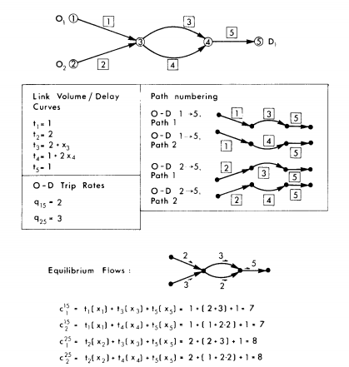

Figure 3.3.1 equilibrium flows and path travel times in a network

In fact, any path-flow pattern that satisfies



would generate the equilibrium link-flow pattern in this example.

Besides, the objective function of the UE minimization consists of a sum each element of which is an integral of an increasing function. The Hessian of each integral



Is positive definite. Thus each integral is strictly convex, and the sum of which is strictly convex also. Then the objective function of the UE program is strictly convex and has only one minimum.

**3.4 The system-optimization formulation**

The UE minimization program lacks an intuitive interpretation, and just is an efficient method for solving the user equilibrium. This section replaces the original objective function with the total travel time spent in the network. This program can be expressed as follows:  
 [3.19a]

Subject to

[3.19b]

[3.19c]

Program [3.19] is known as the ***system-optimization program***. *The flow pattern that minimizes the program result only from joint decisions by all motorists to act so as to minimize the total system travel time rather than their own.* In other words, at the SO flow pattern, drivers may be decrease their travel time by unilaterally changing routes. The SO flow pattern is not stable and should not be used as a model of actual behavior and equilibrium. In some special cases, the SO solution is identical to the UE solution.

The significance of the SO formulation, in conjunction to the resulting flow pattern is that the value of the SO objective function may serve as a yardstick by which different flow patterns can be measured.

The necessary conditions for a minimum for the SO program are given by the first-order condition for a stationary point of the following Lagrangian program:  
 [3.20]

The variable is the Lagrangian multiplier (or dual variable) associated with the flow conservation constraint of O-D pair  (Eq. [3.19b]).

The first-order conditions for a stationary point of Eqs.[3.20] are



Again, the asterisks denoting the optimal solution in terms of and have been omitted, as in Eqs.[3.9].

Conditions [3.21b] and [3.21c] simply restate the flow conservation and nonnegative conservations, respectively.

Condition [3.1a] can be expressed explicitly by deriving the partial derivatives of the Lagrangian with respect to the path flows. These derivatives are given by:  
     [3.22]

The second term of Eq. [3.22] is similar to the second term of Eq. [3.10] and therefore (see Eq. [3.14])

        [3.23]

The second term on the right-hand side of the Eq. [3.22] is given by

[3.24]

Let



The travel time can be interpreted as the marginal contribution of an additional traveler on the link to the total travel time on this link. It is the sum of two components: is the travel time experienced by that additional traveler when the total link flow is , and the is the additional travel time burden that this traveler conflicts on each one of the travelers already using link . Eq. [3.24] can be written as:  
 [3.25]

Where  is the marginal total travel time on path  connecting O-D pair .

The first-order condition for the SO program can now be written as



Equations [3.26a] and [3.26b] state that, at optimality, the marginal total travel times on all used paths connecting a given O-D pair are equal. The flow on a given route is zero only if the marginal total travel time on this route is greater than or equal to the marginal total travel time on the used routes. The value of the dual variable at optimality is the marginal travel time on all used paths between and .

For the solution of the program SO to be unique, it is sufficient to show that the Hessian of is positive definite. A typical term of this Hessian can be obtained by taking the derivative of the objective function with respect to and , that is ,



And

[3.27]

As in the UE program, this result represents a diagonal Hessian with nonzero terms given by Eq. [3.27]. This Hessian is positive definite if all those terms are positive, which is the case if all link performance are convex, thus. Consequently, the SO program has a unique minimum in terms of link flows.

**3.5 User equilibrium and system optimum**

It is interesting to note that when *congestion effects* are ignored, both UE and SO programs will produce identical results.

Imagine a network where . The SO objective function would be

 [3.28a]

And the UE objective function

[3.28b]

Which is identical to the SO objective function .

Minimizing the objective function shown in Eqs. [3.8] subject to the flow constraints [3.19b] and [3.19c], the program becomes:  


Subject to





The problem here is to find the flow pattern that minimizes the total travel time over the network, given the link travel times and the O-D matrix. All flow for a given O-D pair, , is assigned to the minimum-travel-time path connecting this pair. All other paths connecting this O-D pair do not carry flow. Consequently, this traffic assignment procedure is known as ***"all-or-nothing" assignment.*** The resulting flow pattern is both an equilibrium situation (since no user would be better off by switching paths ) and an optimal assignment (since the total travel time in the system is obviously minimized).

The similarity in the structures of the SO and UE programs can be expressed in various ways. For example, if the travel time over the network are expressed in terms of (as shown in Eq. [3.24]), the solution of the UE program with these travel times will produce the SO flow pattern. Similarly, the SO formulation with link travel-time functions given by

[3.30]

Will result in a UE flow pattern.

In cases in which the flow in the network is relatively low, the marginal travel time on each link, is very small due to the shape of the link function (see Figure 3.2), the slope of this function is very small for low flow. In this case, the UE and SO flow pattern are similar since the travel time is insensitive to additional flows. The situation, then, is close to the fixed travel-time case described in Eqs. [3.28].

As the flows between origins and destinations increase, the UE and SO patterns become increasingly dissimilar. Consider the example network shown in Figure 3.5.1.

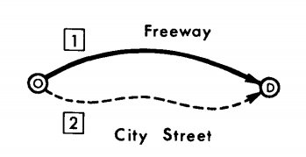

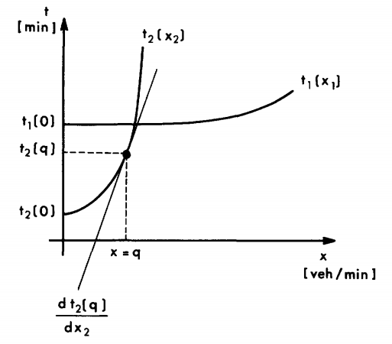

Figure 3.5.1 User equilibrium and system optimization

If the total O-D flow is ,the UE solution will be as shown in the figure. However, , that is, this solution is not the solution of system optimization. The SO solution to this problem may include some flow using the top route as well. Recall the last section, in the SO solution, all the marginal travel times for all used paths on a given O-D pair are equal. That is, the SO flow pattern is achieved only when

 [3.30]

The "Braess's paradox" indicates that the ultimate flow pattern resulting from the UE principle after investments in urban network must decrease the total travel time in SO, then the investments is meaningful.